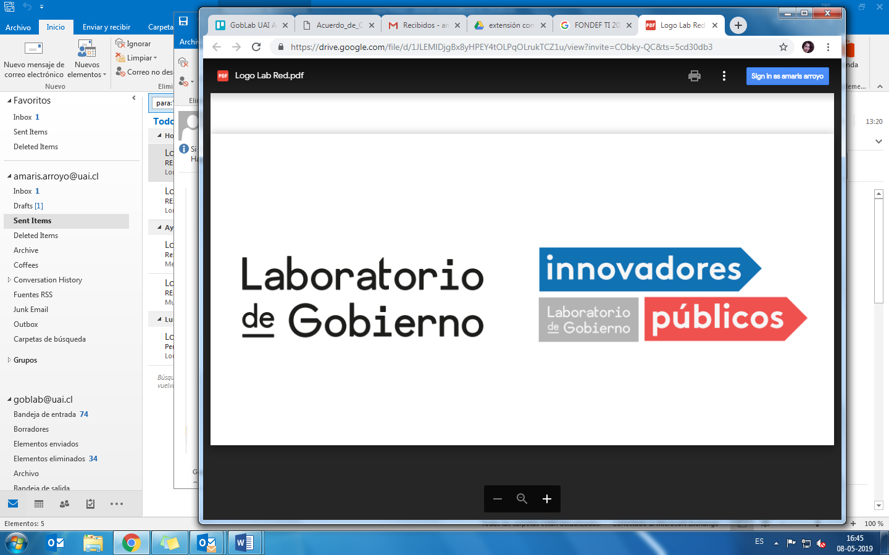

**Optional Supplemental Reading Materials**

Athey, Susan & Imbens, Guido. (2019). Machine Learning Methods Economists Should Know About. <https://arxiv.org/abs/1903.10075>

Buenadicha Sánchez, César; Galdon, Gemma; Hermosilla, María Paz; Loewe, Daniel; Pombo, Cristina. “La Gestión Ética de los Datos”. Marzo 2019. <http://dx.doi.org/10.18235/0001623>

Foster, Ian; Ghani, Rayid; Jarmin, Ron S; Kreuter, Frauke; and Lane, Julia. 2016. Big Data and Social Science: A Practical Guide to Methods and Tools. Chapman & Hall/CRC. Chapter 6: Machine Learning.

Mullainathan, Sendhil, and Jann Spiess. 2017. "Machine Learning: An Applied Econometric Approach." Journal of Economic Perspectives, 31 (2): 87-106. <https://pubs.aeaweb.org/doi/pdfplus/10.1257/jep.31.2.87>

Provost, Foster & Fawcett, Tom. Data Science for Business: What You Need to Know about Data Mining and Data Analytics Thinking (2013). Chapter 1 & 2.

Varian, Hal R. 2014. "Big Data: New Tricks for Econometrics." Journal of Economic Perspectives, 28 (2): 3-28. DOI: 10.1257/jep.28.2.3